Business Question and Visualization Report

Date | 21-September-2026
Team ID | MCA
Project Name | Smartphone Usage, Digital Addiction & Well-Being Analytics
Maximum Marks | 5 Marks

Visualization development refers to the process of creating graphical representations of data to facilitate understanding, analysis, and decision-making. The goal is to transform complex datasets into visual formats that are easy to interpret, enabling users to gain insights and make informed decisions. Visualization development involves selecting appropriate visual elements, designing layouts, and using interactive features to enhance the user experience. This process is commonly associated with data visualization tools and platforms, and it plays a crucial role in business intelligence, analytics, and reporting
Business Questions and Visualisation
The process involves defining specific business questions to guide the creation of meaningful and actionable visualizations in Power BI. Well-framed questions help in identifying key metrics, selecting relevant data, and building visualisation that provide insights.

1. What percentage of users are addicted?
Visualization: KPI Cards — Count of User Count (7.5K), Users Addicted (5K), % Addicted (0.71)
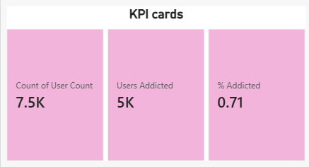

2. How does screen time differ between addicted and non-addicted users?
Visualization: Bar chart — Avg Screen Time: Addicted vs Non-Addicted

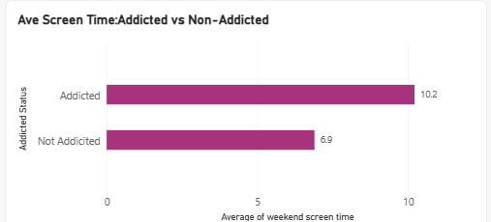

3. Is there a relationship between screen time and sleep hours?
Visualization: Scatter chart — Screen Time vs Sleep Hours (colored by addicted label)

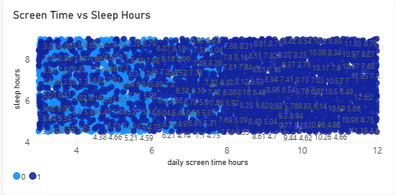

4. Does addiction rate vary by age group?
Visualization: Bar chart — Addiction Rate by Age Group

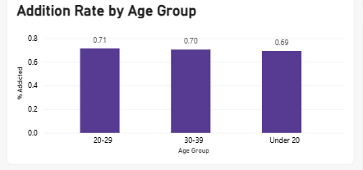

5. How does sleep differ between addicted and non-addicted users?
Visualization: Bar chart — Avg Sleep: Addicted Users vs Non-Addicted Users

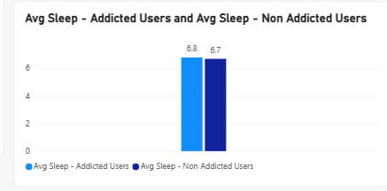
6. Does screen time spike on weekends?
Visualization: Bar chart — Weekday vs Weekend Screen Time

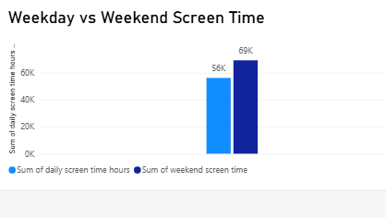

7. How are daily notifications distributed across users?
Visualization: Line chart — Notifications per Day Distribution

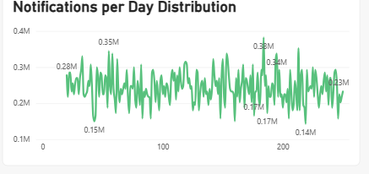

8. How is addiction severity distributed among users?
Visualization: Donut chart — Addiction Level Breakdown (Moderate 38.3%, Severe 32.5%, Mild 18.3%, None 10.9%)

